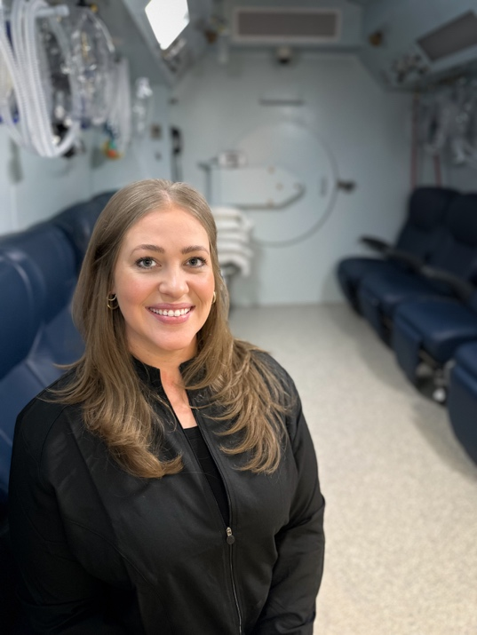
Candace Hansen Gillingham is a founding member of Trident LPW and Director of Hyperbaric Medicine. She has established a reputation for delivering hyperbaric care at the highest standard—defined by precision, safety, and an uncompromising commitment to patient outcomes.
With over a decade of experience across emergency medical services and advanced hyperbaric operations, Candace brings a rare depth of clinical expertise paired with exceptional operational leadership. She has led sophisticated hyperbaric programs utilizing both mono-place and multi-place chamber systems and is known for cultivating elite clinical teams that operate with discipline, discretion, and clinical excellence.
Candace holds credentials as a Certified Hyperbaric Technologist (CHT) and Certified Hyperbaric Specialist (CHS) and is a licensed Paramedic (EMT-P). She remains actively engaged in shaping the field through professional organizations, safety leadership, and ongoing clinician development—ensuring the programs she leads consistently reflect the most advanced standards in hyperbaric medicine.
Her foundation in high-acuity 911 paramedic care informs her decisive leadership style and refined clinical judgment. Her excellence has been recognized with honors including ALS Provider of the Year, Cardiac Award, and Trauma Award—distinctions that reflect both technical mastery and a deep commitment to patient care.
Beyond clinical operations, Candace is a respected voice in hyperbaric medicine. She is a featured speaker at industry symposiums, presenting on complex topics such as barotrauma mitigation and hyperbaric applications for traumatic brain injury, and has contributed to professional literature on osteoradionecrosis and osteomyelitis. She also advises and mentors program leaders, helping to shape high-performing, safety-driven hyperbaric programs.
Candace’s path into medicine began early and has evolved into a career defined by intention, discipline, and leadership. Today, she is known not only for her clinical and operational expertise but for her ability to build environments where excellence is expected and delivered consistently. At Trident LPW, her philosophy is clear: exceptional care is never accidental—it is designed, refined, and executed with purpose.
Outside of her professional work, Candace lives with her husband and their two sons. She embraces a quieter, more intentional lifestyle—spending time farming and creating a life centered on family, balance, and connection.

