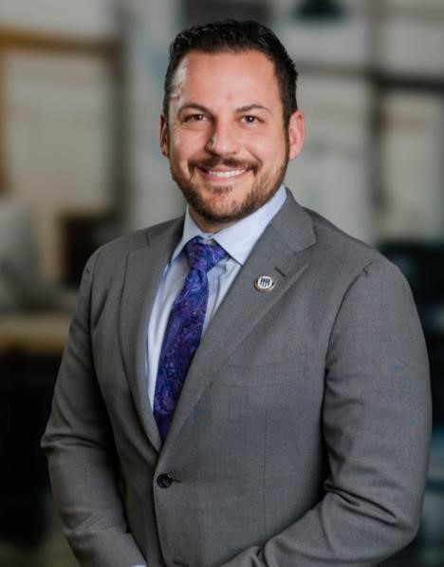
Kyle R. Dixon, MBA
Founder | Owner | Executive Director
What I Bring to the Team: I challenge limits—mine and others’—with discipline and integrity because I believe adversity, when met with clarity and purpose, can be transformed into growth, growth into performance, and performance into lasting impact and freedom. My deeper purpose is to build a life and career that creates opportunity not only for myself, but for the people and organizations around me—developing capable leaders, strengthening communities, and generating the financial independence and lifestyle that allow me to live intentionally, continue discovering new possibilities, and give back in meaningful ways.
I pursue this purpose by leading with clarity, accountability, and disciplined standards. I focus on aligning people, priorities, and resources while installing scalable systems that turn complex challenges into structured execution. By building trust, empowering leaders at every level, and fostering environments where high expectations and psychological safety coexist, I develop teams that can perform consistently under pressure. My approach centers on diagnosing root problems quickly, implementing practical operating frameworks, and cultivating leaders who sustain performance without constant oversight.
As I transition from military service into civilian leadership, I will apply these principles to build and lead high-performing organizations that convert strategy into measurable results. I will focus on strengthening operational discipline, improving performance systems, and guiding organizations through complexity and change. Through this work, I intend to create enduring value for the organizations I serve, accelerate my growth into senior executive leadership roles, achieve financial independence, and build a life defined by purposeful work, continuous growth, and meaningful impact.

Gallup Strengths: Relator, Restorative, Command, Arranger, Significance

Education: Masters in Business Administration from College of William and Mary.

